TWS Bluetooth Earphone User Manual

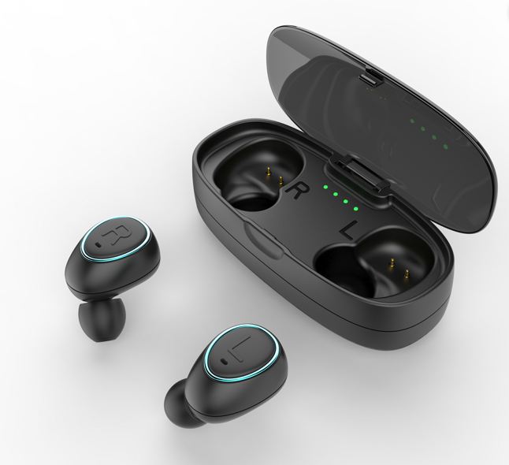

SAFETY CAUTION
- Avoid playing your earphone at high volume levels. Some studies have concluded that prolonged and extensive exposure to noise in excess of 95dB may impair hearing.
- Never wear your earphones while operating a motorized vehicle. It may create a traffic hazard.
- Exercise caution if you are wearing your earphones while engaged in activities such as walking, jogging, cycling etc. The distraction may cause an accident.
- Do not use the product in too high or too low temperature environment (Below -10 degree centigrade or Above 45 degree centigrade).
Extreme temperatures can cause deformations, and will reduce the charging capacity of the device.
- Does not use in wet conditions, water can cause severe damage to the earphones.
- Do not use wet hands when operating equipment, equipment damage caused by water does not make the warranty scope.

PRODUCT IMAGE
Charging case
MFB buttons

FUNCTION

- Power On：Long Press MFB button around 1.5 seconds. At this point, the Red and blue indicator lights will flash respectively. The earphone will announce "Turn on" prompt tone through the earphone.
- Power Off：Long Press MFB button around 3 seconds. At this point, the Red and blue indicator lights will flash respectively. The earphone will announce "Turn on" prompt tone through the earphone.
- Pairing：Long press MFB button of L and R 1.5 seconds respectively, and then double-click on one of the headphones MFB button (to set to host). Once connected, the hose will flash the blue and red lights at the same time.
- Connect with Phone：Open Device “setting --- Bluetooth --- click “WC0696”. Once connected the indicator will turn blue and begin to flash. At this point the earphones will announce “Connected".
5. Music play/pause：Press R or L MFB buttons to Play or pause music playing.
6. Answer Call: Press either MFB button when there is an incoming call.
7. Hang up Call: During a call, Press the MFB button to hang up.
8. Recent Call number redial：When the phone is connected to a Bluetooth headset, Double-click the MFB button.
9. Reject an incoming Call：Double-click the MFB button when call is incoming.
10. Cancel outgoing call：Short press the MFB button when in the dialing state.
11. Low Battery alarm ：When the headset power is less than 20%, it will flash red for 5 seconds and earphone will announce "low charge prompt" 5 minutes afterwards.
12. Low battery shutdown：When the earphone is running on low battery, the earphone will automatically shut down. At this point, the red light will flash around the MFB button and the earphone will announce “powering off”.
13. Automatic Connection: When the earphones are connected successfully to the desired device, you will no longer need to repeat the step of pairing. Pairing will occur naturally when the earphones are turned on.

RESTORE ORIGINAL SETTINGS
To restore the earphones back to factory settings, long press the MFB buttons for 8 seconds. At this point two red and blue lights will flash.
ONE EARPHONE USE
One earphone can be paired directly to your device, without the use of the second.

1. Single open Pairing mode：Long Press the MFB button on either the R or L earphone. After 1.5 seconds, the Red and blue lights will flash respectively. As with pairing 2 earphones together, the earphone will announce "turn on".

Functionality is as per above (when pairing 2 earphones).

CHARGING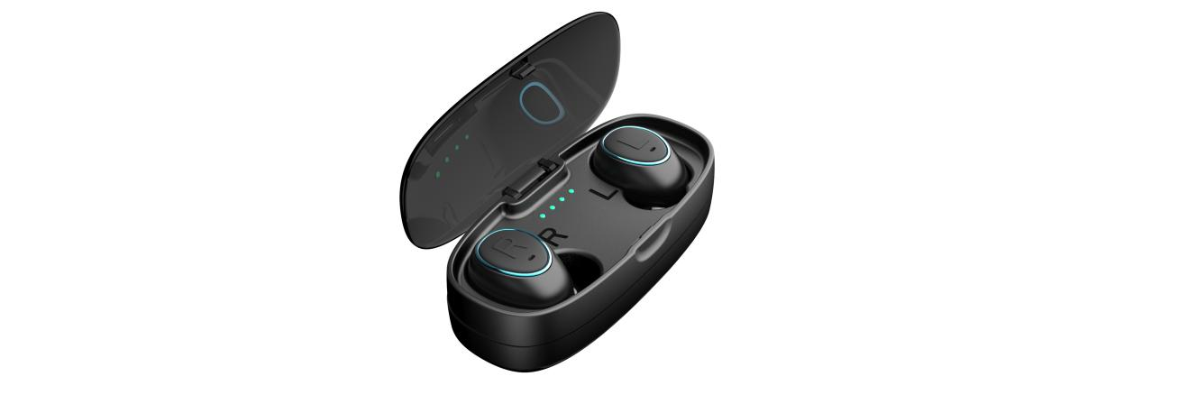
To charge, put both the L and R earphones into the supplied charging case. Charging will begin when the lid is closed.

A red light will illuminate to indicate that the earphones are charging on the earphones. When fully charged, this red light will turn off.

There is also a power level indicator of the charge left in the charging dock.
100% Power | ●●●●
75% Power | ●●●
50% Power | ●●
25% Power | ●

TECHNICAL SPECIFICATION

Bluetooth Version：V4.1
Support：A hands-free headset, Bluetooth audio transmission
Bluetooth Distance：10M
Level：Class 2
Working frequency：2.402~2.48GHz
Charging voltage：5V
Battery capacity ：50mAh
Charging time ：1.5 hours
Playing time：2 hours
Standby time ：110 hours
Music Playing: 2 hours
Emergency power source parameters
- Dual USB Port
- Input ：5V~1 A
- Output：5V~1 A
4. Charging case battery capacity ：400mAh

